NIST RMF Compliance for Log360
Strengthen data protection and meet NIST RMF compliance with Log360.
Region: USA | Type: Data Privacy, Government/Public Sector, Industry Standard, Incident Management | Category: Compliance | Pricing: Free

Overview
The NIST RMF compliance extension in Log360 helps organizations meet the NIST Risk Management Framework (SP 800-37), a structured NIST process for integrating security, privacy, and supply chain risk management into system development life cycles for federal agencies and contractors by providing centralized log management, continuous control monitoring, and real-time threat detection. The platform supports NIST RMF requirements for security categorization, access control, audit and accountability, incident response, privileged access, configuration management, and continuous monitoring.
For Security Categorization and Risk Preparation, Log360 provides computer auditing, user auditing, and event log reports that support system inventory and baseline documentation essential to accurate security categorization. To address Access Control Implementation, the platform tracks Windows and Unix logon events, failed access attempts, AD logon records, and network device logons to enforce and validate access control requirements. The extension also supports Audit and Accountability Controls by providing capabilities that aggregates event logs, system events, and process tracking records across Windows, Unix, and Active Directory to maintain comprehensive audit trails.

Key Features
- Incident Response Planning and Execution: Log360 monitors network attack events, Windows threat detection, malware alerts, Unix threats, and firewall violations to support rapid incident identification and response.
- Privileged Access and Configuration Management: Log360 audits policy changes, group changes, SUDO commands, GPO settings, and password management to enforce CM and privileged access requirements.
- System and Communications Protection: Log360 tracks network device configuration changes, policy updates, registry modifications, and file system changes to enforce system integrity requirements.
- Continuous Monitoring and Control Assessment: Log360 monitors network attack patterns, firewall policy compliance, threat detection events, and vulnerability indicators to support ongoing RMF continuous monitoring requirements.
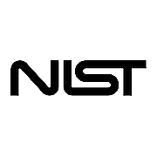
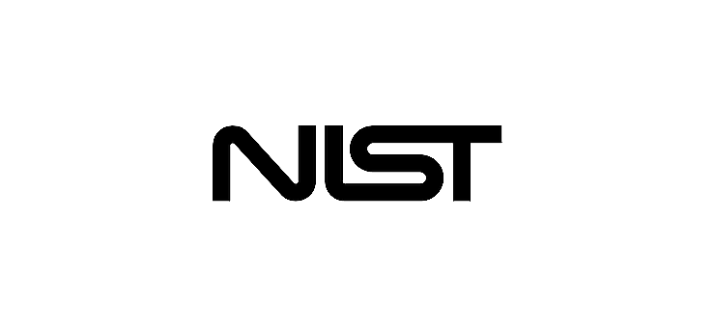
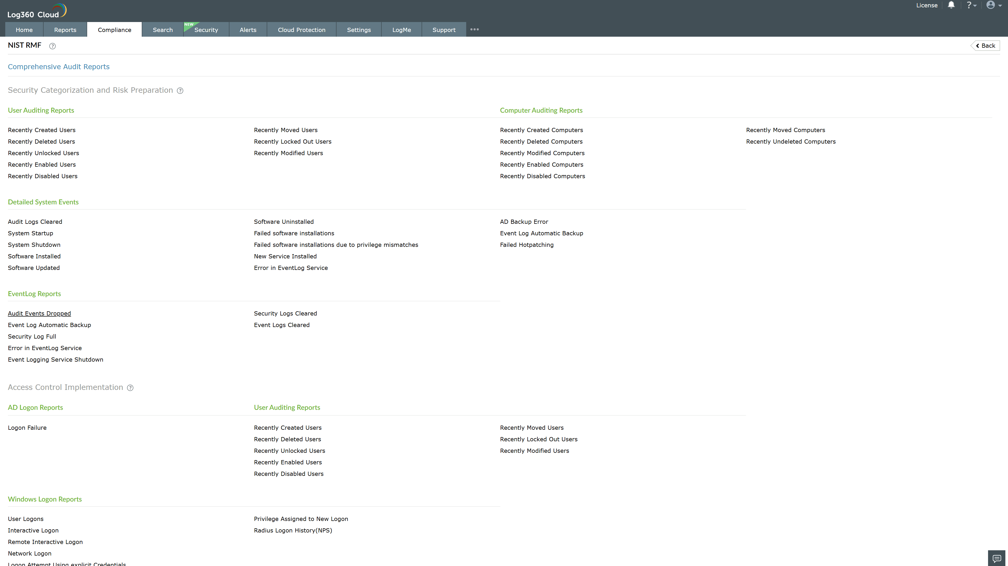
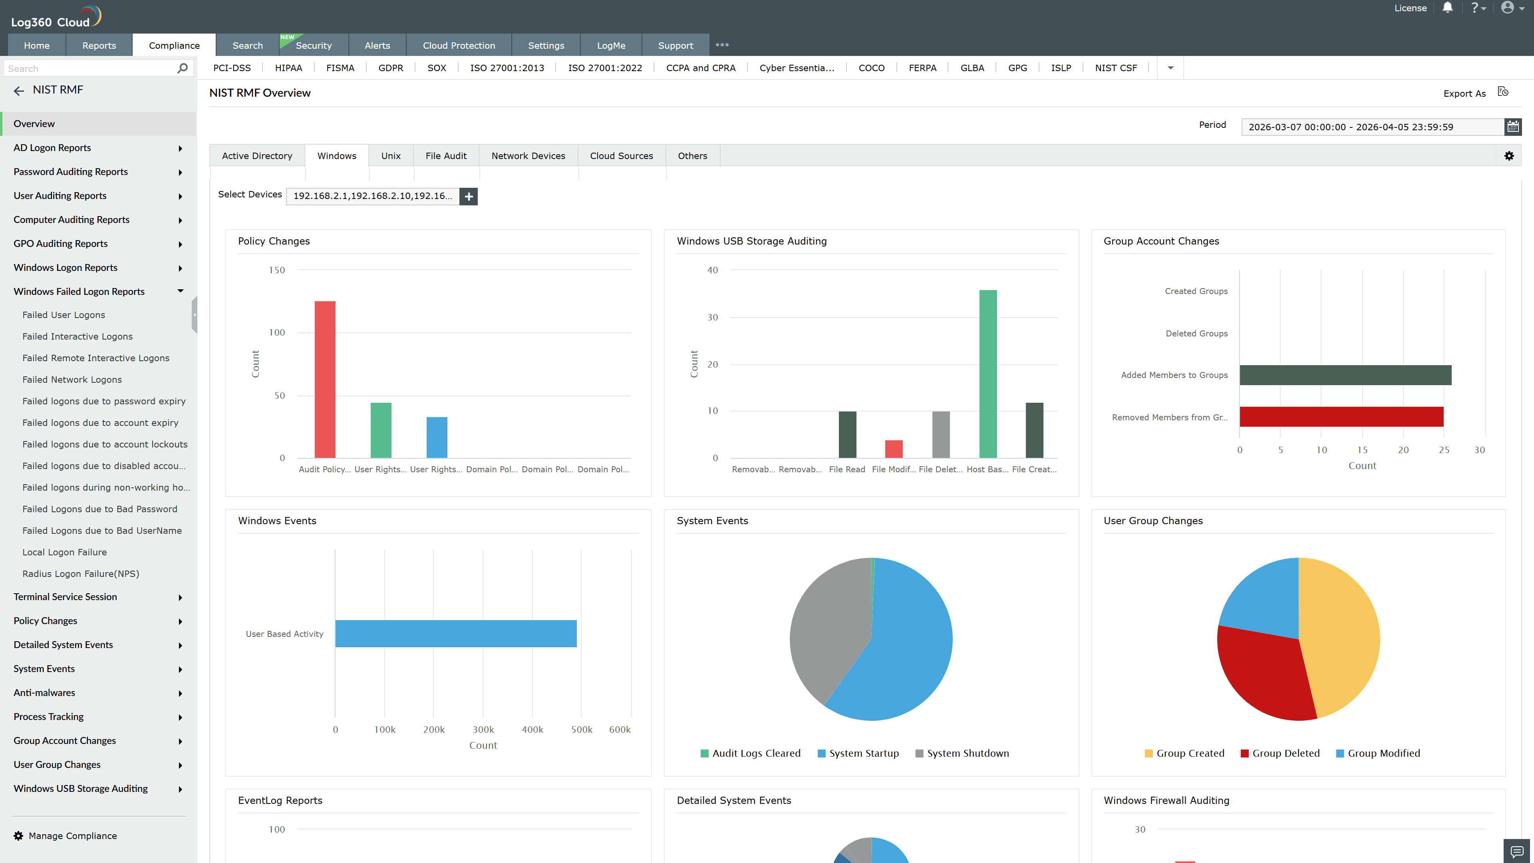
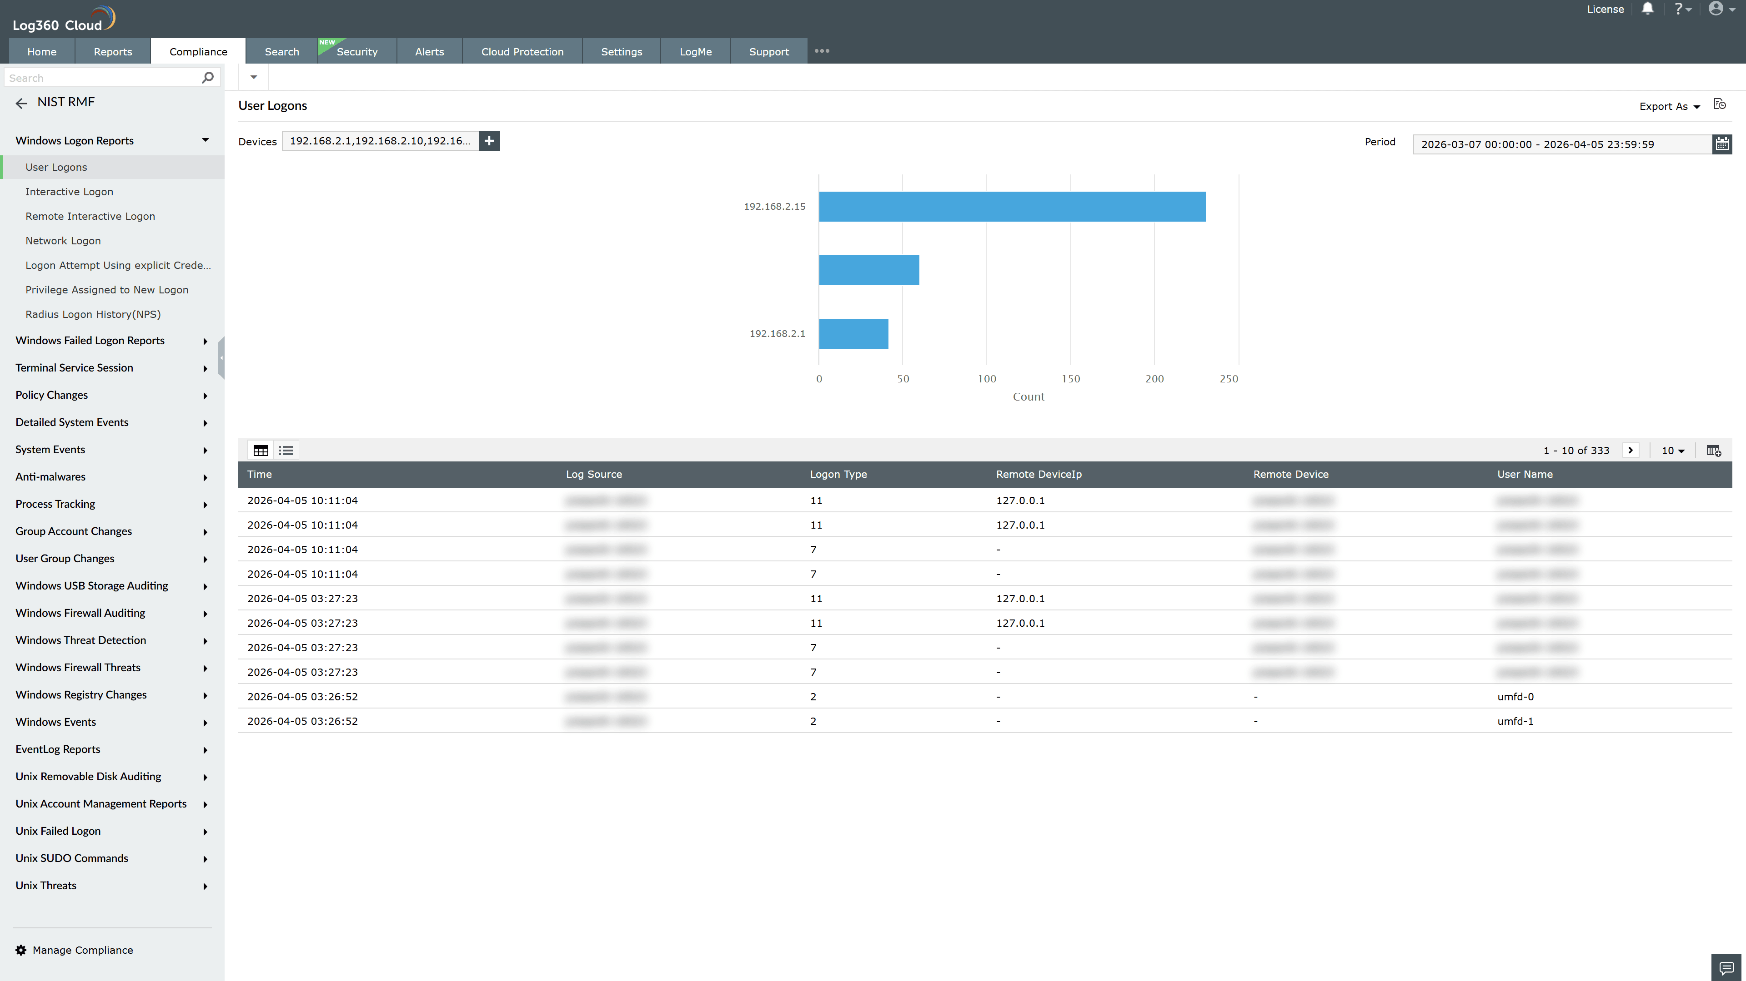
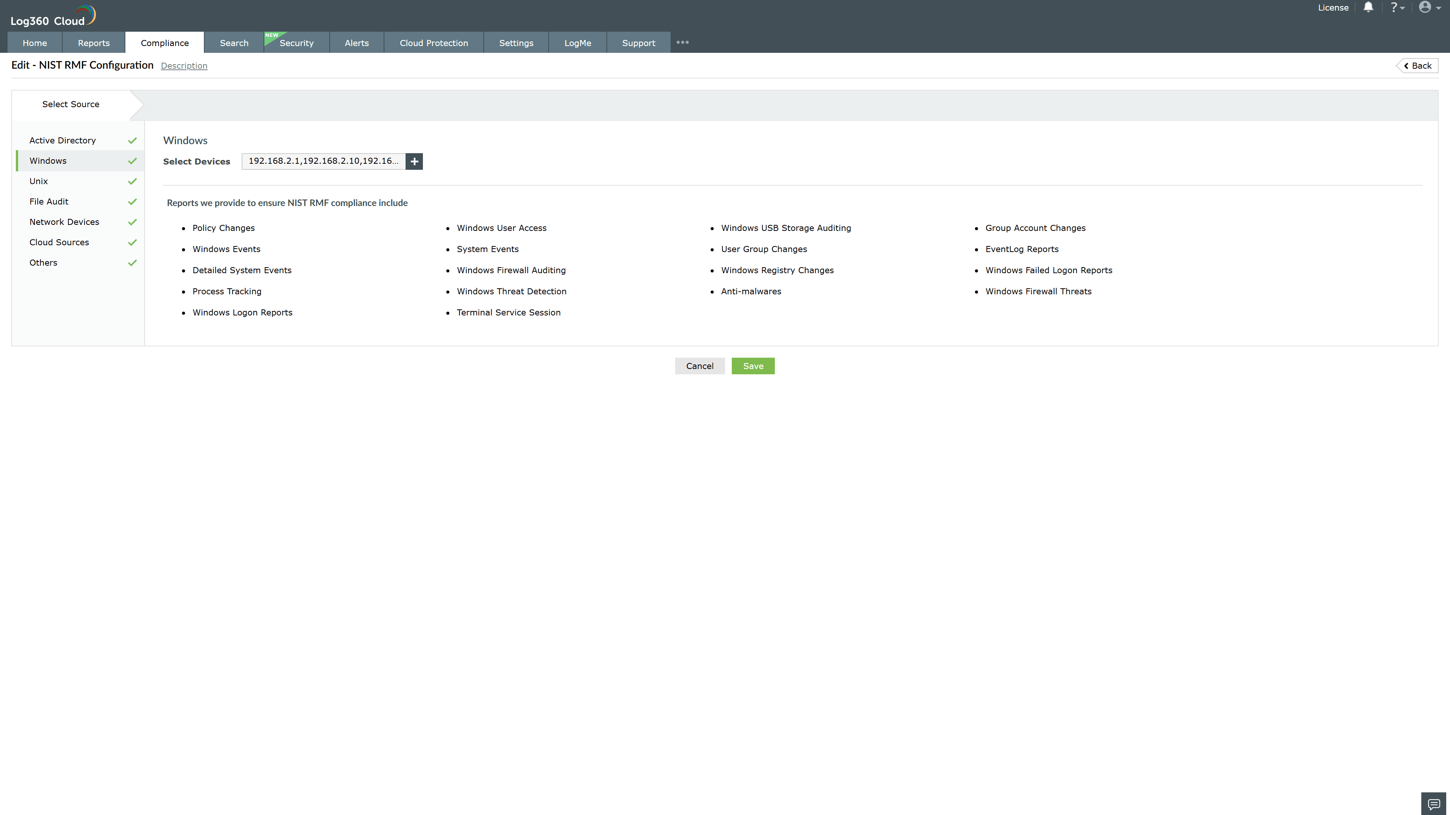
Valid Submission : Yes
Supported Editions : Free, Basic, Standard, Professional, MSSP
Help Document : https://www.manageengine.com/log-management/help/integrations/compliance-extensions.html
Help Video : Not provided
Tags : Log360, Compliance, Privacy monitoring, Data privacy, Regulatory compliance
Supported DCs : US, IN, JP, CA, AU, UK and EU
Privacy Policy:
Terms of Service:
Release Notes:
Predefined reports for the NIST RMF.

